Batch: B2 Roll No.: 16010121200
Experiment No. 04
Grade: AA / AB / BB / BC / CC / CD /DD

Signature of the Staff In-charge with date

Title: Make map using QGIS

Objective:
Make a map showing point, line and polygon features and export it.
Understand the key cartographic elements that must be present to allow interpretation of a map.

Expected Outcome of Experiment:

CO | Outcome
CO3 | Apply software processing techniques to prepare statistical modelling for geospatial healthcare and text data.

Books/ Journals/ Websites referred:
https://qgis.org/en/site/forusers/download.html
https://www.mapmarker.app/webapp/#/
https://docs.qgis.org/3.28/en/docs/user_manual/index.html

Import, create, edit data:
Create data using Map Marker:
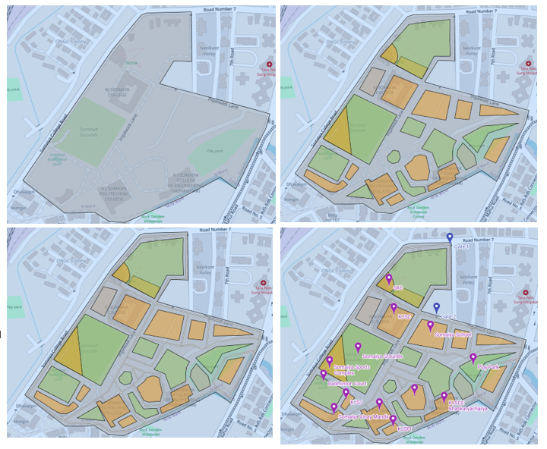
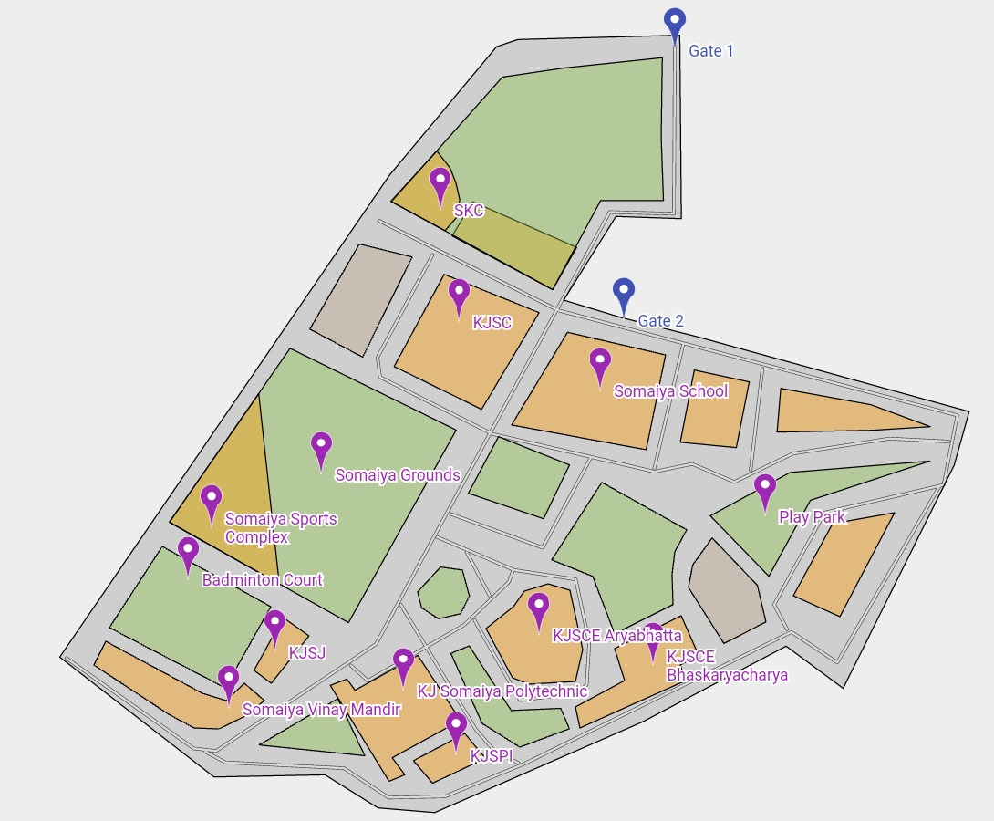
Export map as KMZ
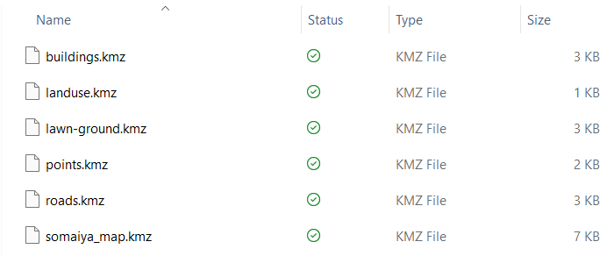
Import into QGIS
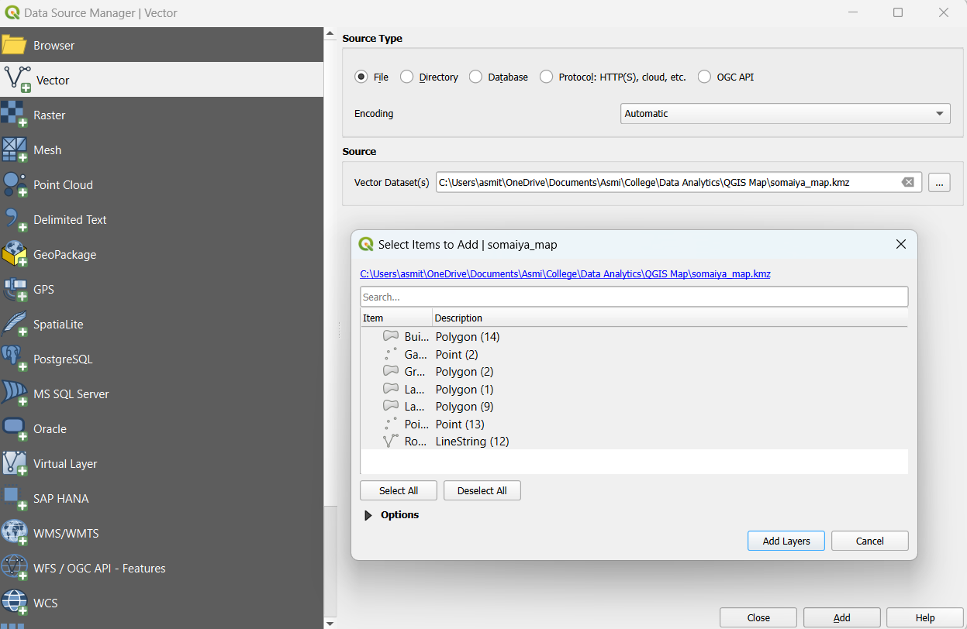

Processing vector data, raster data
Vector data
It consists of points, lines, and polygons.
QGIS application groups vector features into layers. Features in a layer have the same geometry type (e.g. they will all be points) and the same kinds of attributes (e.g. information about what species a tree is for a trees layer).
QGIS application allows creating and modifying the geometry data in a layer – a process called digitising. If a layer contains polygons (e.g. farm dams), the GIS application will only allow creating new polygons in that layer.
Raster data
It is made up of a matrix of pixels (also called cells), each containing a value that represents the conditions for the area covered by that cell.
Raster can be used to model water flow over the land surface. This information can be used to calculate where watersheds and stream networks exist, based on the terrain. Raster data are also often used in agriculture and forestry to manage crop production. For example, with a satellite image of a farmer’s lands, you can identify areas where the plants are growing poorly and then use that information to apply more fertilizer on the affected areas only. Foresters use raster data to estimate how much timber can be harvested from an area.
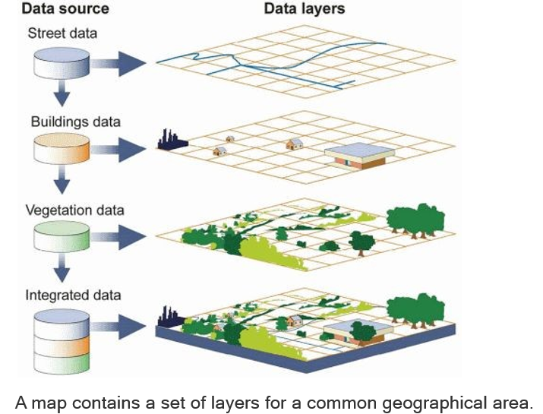

Making maps - Make a map which you can export and include in a document
Map made in QGIS:
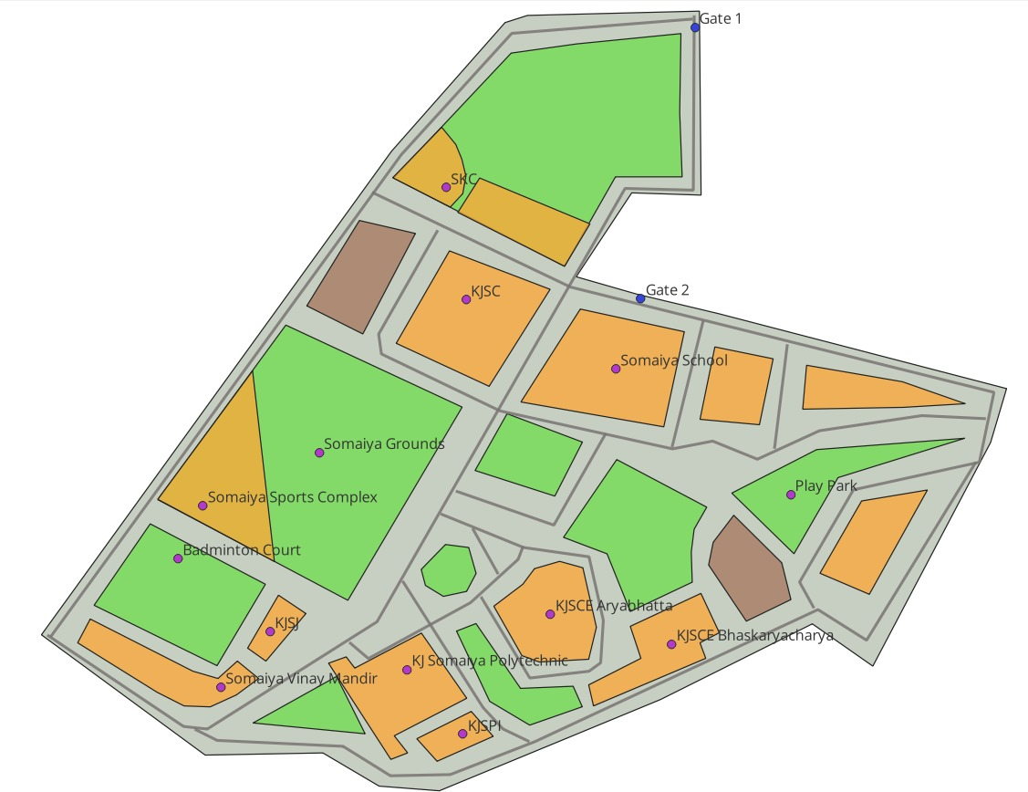

Accessibility analysis
Finding shortest path from ‘Gate 1’ to ‘KJSCE Bhaskaracharya building’:
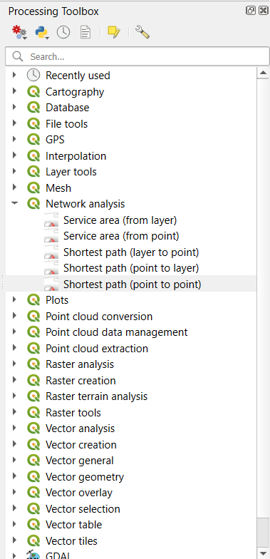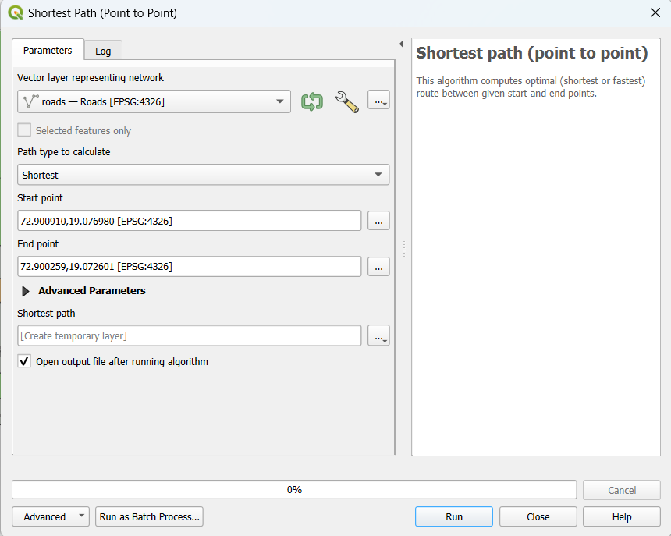
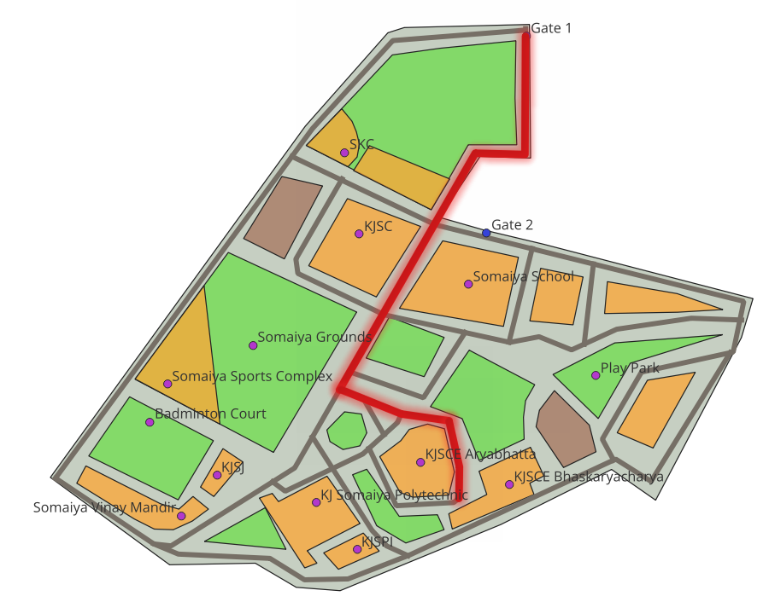

Post-lab questions:
How map maker feature of QGIS is helpful in real time?
Map production is the process of arranging map elements on a sheet of paper. It helps the average person understand what it is about, even without many words.
Maps are usually produced for presentations and reports, where the audience do not have a professional background in GIS. Because of this, a map must be effective in communicating spatial information.
The map maker feature of QGIS helps to achieve this objective in a much quicker and easier way.
Conclusion:
Used QGIS to conduct data analytics on map data in vector form.
Understood applications of data analytics in GIS.

